Epic Hero: What are the characteristics of a hero? What characteristics would you give a hero if you were to invent one? Put your notes to the right of the image.
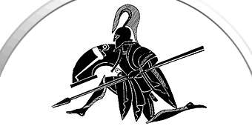
This image represents the epic hero journey, also known as the monomyth. The stages begin at the top and travel counter-clockwise:
- Birth/Home (in the 12:00 position)
- Call to Adventure
- Helpers/Amulet
- Crossing the Threshold (in the 9:00 position)
- Tests
- Helpers
- Climax/Final Battle (in the 6:00 position)
- Flight
- Return (in the 3:00 position)
- Elixir
From Beowulf to Batman, storytellers have been reimaging the Epic Hero, but the basic hero pattern remains the same today as it was when the Anglo-Saxons lived. Below is “Apology Girl” from the television show “Breaking Bad.” Based on the drawing, what are Apology Girl’s character traits?
Task: Create your own “Epic Hero” and name your hero. Also, give the hero characteristics and put these on your paper.

